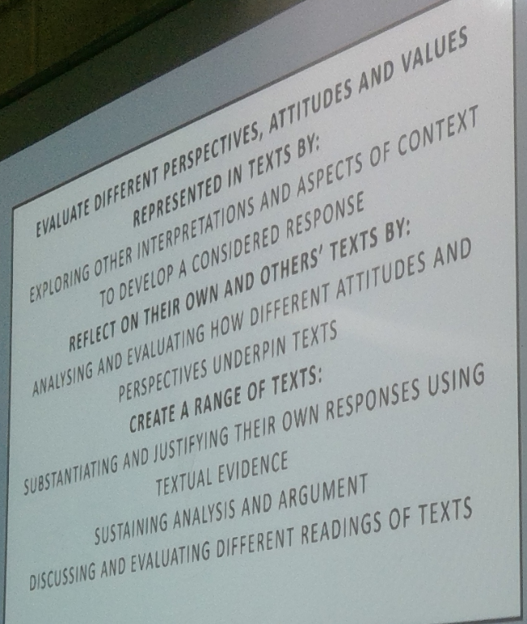

Study how the film offers more than one perspective.



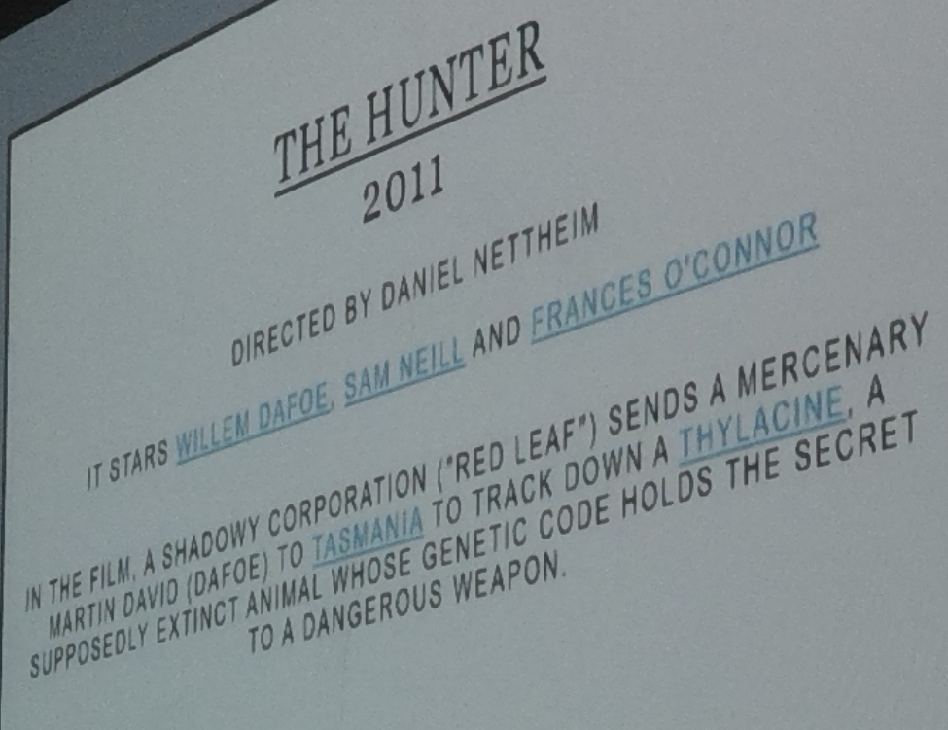

↑ Good summary of the film to put in essay (the marker may not have seen the film).

Hegemonic masculinity: A practice that legitimises men's dominant position in society and justifies the subordination of the common male population and women, and other marginalized ways of being a man.

Traditional traits associated with hegemonic masculinity:

1. Strong.
2. Heterosexual.
3. Authoritarian.
4. Resilient.
5. Competitive.
6. Powerful.
7. Brawny.
8. Untouchable.

Women become disempowered when hegemonic masculinity is upheld.

Traditional traits associated with female stereotypes:

1. Weak.
2. Feeble.
3. Fragile.
4. Delicate.
5. Compliant.
6. Alluring.
7. Submissive.
8. Vulnerable.